Inspection review

What is Inspection review
# Source: Chatgpt (GPT‑5 Mini) at [8/14/2025]
Inspection review is the most formal type of static review in software testing — think of it as a structured, rules-driven “code/test/documents audit” where the main goal is to find defects, not discuss solutions during the meeting.

Key Points About Inspection
# Source: Chatgpt (GPT‑5 Mini) at [8/14/2025]
- Objective: Detect defects early in software artifacts (requirements, test cases, code, design docs, etc.)
- Formality: Highly structured with defined roles, a checklist, pre-meeting preparation, and documented findings.
- Origin: Based on Michael Fagan’s inspection process (IBM, 1970s).
- Output: Formal defect log and metrics (number of defects found, severity, time spent, etc.).

Roles in Inspection
# Source: Chatgpt (GPT‑5 Mini) at [8/14/2025]
- Moderator – Plans the inspection, runs the meeting, keeps it on track.
- Author – Creator of the document under review (e.g., tester who wrote test cases).
- Reviewers/Inspectors – Experts who check the work for defects.
- Recorder/Scribe – Notes every defect found.
- Manager (optional) – Monitors quality trends.

Typical Inspection Steps in Testing
# Source: Chatgpt (GPT‑5 Mini) at [8/14/2025]
- Planning – Moderator schedules review, selects reviewers, sends materials.
- Overview (optional) – Author explains context to reviewers.
- Preparation – Reviewers study the document alone, using checklists.
- Inspection Meeting –
  - Moderator leads discussion.
  - Reviewers call out defects (ambiguities, missing coverage, incorrect expected results, etc.).
  - No fixing or problem-solving in the meeting — just logging defects.
- Rework – Author corrects the defects.
- Follow-up – Moderator checks fixes and closes the review.

Real-World Example in Testing
# Source: Chatgpt (GPT‑5 Mini) at [8/14/2025]
Artifact: Test cases for an online shopping cart
Checklist Items:
- Is every functional requirement covered?
- Are boundary values tested?
- Is expected result specific and measurable?
- Are preconditions clearly stated?
During Inspection Meeting:
- Reviewer:
“In Test Case #12, expected result says ‘order placed successfully’ — missing exact confirmation message as per REQ-05.”
- Reviewer:
“No test case for cart quantity = 0, which is a boundary value.”
- Scribe logs these as defects in JIRA with tags “Test Case Review Defect.”

Difference from Walkthrough & Technical Review
# Source: Chatgpt (GPT‑5 Mini) at [8/14/2025]
- Walkthrough → informal knowledge-sharing, no defect metrics.
- Technical Review → formal, but may include discussion and fixes during meeting.
- Inspection → most formal, strict process, defect logging only, uses checklists, fixes happen after the meeting.

Technical Review vs Inspection
# Source: Chatgpt (GPT‑5 Mini) at [8/14/2025]
Here’s the clear, real-world breakdown of Technical Review vs Inspection in software testing, so you can actually tell them apart when they happen in practice:

1. Purpose
# Source: Chatgpt (GPT‑5 Mini) at [8/14/2025]
- Technical Review → Evaluate technical quality and suitability of a work product.
  - Example: Reviewing test automation scripts for correct framework usage, maintainability, and performance.
- Inspection → Find defects only (not to discuss solutions) in a formal, measurable process.
  - Example: Reviewing manual test cases line-by-line against requirements using a checklist.

2. Formality
# Source: Chatgpt (GPT‑5 Mini) at [8/14/2025]
- Technical Review → Formal or semi-formal — structure exists, but not as strict as inspection.
- Inspection → Most formal — rigid process with documented roles, checklists, and defect logging.

3. Roles
# Source: Chatgpt (GPT‑5 Mini) at [8/14/2025]
- Technical Review
  - Author
  - Moderator (optional)
  - Peers/Experts (technical specialists)
- Inspection
  - Author
  - Moderator
  - Reviewers/Inspectors
  - Recorder/Scribe
  - (Optional) Manager for oversight

4. Discussion Rules
# Source: Chatgpt (GPT‑5 Mini) at [8/14/2025]
- Technical Review → You can discuss solutions and improvements during the meeting.
- Inspection → No fixing or solution discussion in the meeting — only identify and log defects.

5. Preparation
# Source: Chatgpt (GPT‑5 Mini) at [8/14/2025]
- Technical Review → Reviewers prepare in advance, but flexibility is allowed.
- Inspection → Mandatory pre-meeting preparation with checklists.

6. Output
# Source: Chatgpt (GPT‑5 Mini) at [8/14/2025]
- Technical Review → Recommendations for improvements, plus possible defect list.
- Inspection → Formal defect log + metrics (number of defects, severity, time spent, etc.).

7. Real Testing Examples
# Source: Chatgpt (GPT‑5 Mini) at [8/14/2025]
Technical Review Example
- Artifact: Selenium automation scripts
- Finding: "This script uses hard-coded waits instead of dynamic waits — will slow down execution. Suggest using WebDriverWait."
- Meeting includes brainstorming best implementation.
Inspection Example
- Artifact: Test case document for login feature
- Finding: "Test case for invalid password missing expected error code from REQ-03."
- Logged as defect #TC-001 in JIRA.
- No discussion on how to fix — author will correct later.

Quick Side-by-Side Table
# Source: Chatgpt (GPT‑5 Mini) at [8/14/2025]
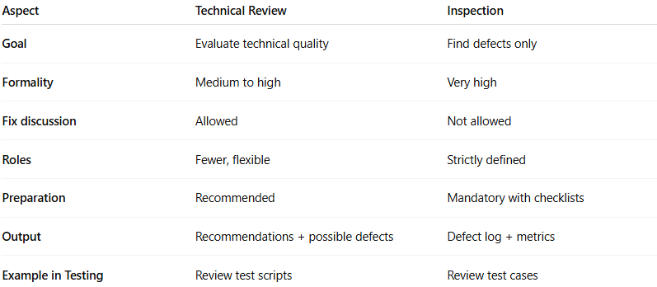
Aspect | Technical Review | Inspection
Goal | Evaluate technical quality | Find defects only
Formality | Medium to high | Very high
Fix discussion | Allowed | Not allowed
Roles | Fewer, flexible | Strictly defined
Preparation | Recommended | Mandatory with checklists
Output | Recommendations + possible defects | Defect log + metrics
Example in Testing | Review test scripts | Review test cases

